**NORTH SALEM CENTRAL SCHOOL DISTRICT**

**PROFESSIONAL LEARNING MASTER PLAN 2024-2025**

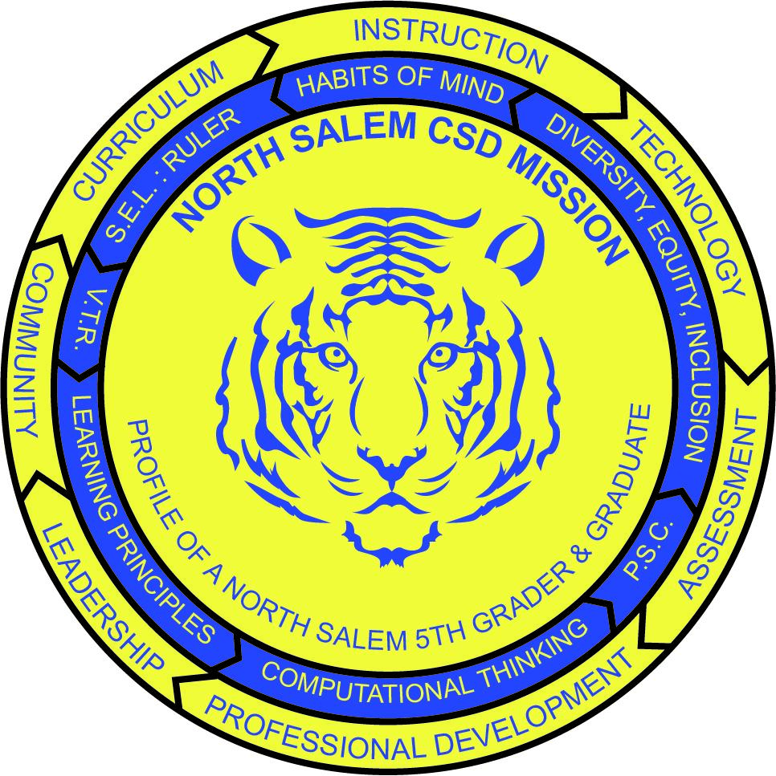

***Engage all students to continuously question, define and solve problems through critical and creative thinking.***

The professional learning committee discusses and plans topics related to curriculum, instruction and professional learning. The Committee meets monthly. Professional Learning Committee Members:

|  |  |
| --- | --- |
| **Christine Contreras,** ENL PQ  **Beth Savarese**, Instructional Coach, PQ  **Sue Quigley,** Paraprofessional MSHS  **Karen O’Brien**, Special Education, PQ  **Dr. Cynthia Sandler**, Library Media Specialist, North Salem MS/HS  **Donna Ulrich**, Kindergarten Teacher, PQ  **Jane Burdett,** STEP Teacher, PQ  **Mariya Perreault**, Science Teacher, North Salem MS/HS  **Katia Castelli**, School Psychologist, North Salem MS/HS | **Jillian Pitaro-Foglia**, Speech Pathologist, PQ  **Liz Wright**, PPS District Coordinator  **Dawn Snowdon,** Assistant Principal, PQ  **Vince DiGrandi**, Principal, North Salem MS/HS  **Denise Kiernan,** Director of Physical Education, Health and Athletics  **Dr. Kate Murphy**, Assistant Principal, North Salem MS/HS  **Dr. Roy Martin**, Principal, Pequenakonck Elementary  **Dr. Julio Vazquez**, Director of Instruction and Human Resources  **Dr. Duncan Wilson**, Superintendent |

|  |  |
| --- | --- |
| **Table of Contents** | |
| **North Salem Central School District Mission Statement & Master Strategies** | 3 |
| **North Salem Profile of a North Salem 5th Grader** | 4 |
| **North Salem Profile of a North Salem Graduate** | 5 |
| **Problem Solving Cycle and Spiral of Continuous Improvement** | 6 |
| **Professional Learning Principles** | 7 |
| **NYS Professional Learning Standards and Indicators** | 8-12 |
| **Triangulation of Data Sources** | 13 |
| **Professional Learning Opportunities & Requirements for CTLE Attainment** | 14-23 |
| **Professional Learning Plan District Best Practices** | 24-26 |
| **Development of Professional Development Plan** | 26 |
| **Purpose of the Professional Development Plan** | 26 |
| **Scope of Student Performance Addressed by the Plan** | 26 |
| **Professional Development Connections to Standards for Student Performance** | 26 |
| **Content of Professional Development Activities** | 27-28 |
| **Effective Professional Development** | 28-29 |
| **Staff Member Responsibilities** | 29 |
| **Leadership Responsibilities** | 29-30 |
| **Evaluation of Long-term and Yearly Professional Development Plans** | 30 |
| **Curriculum Review Cycle** | 30 |
| **Registration Process** | 30 |
| **Record Keeping** | 31 |
| **North Salem Central School District Professional Development Team** | 31 |
| **Collaboration with the Hudson River Teacher Center** | 32 |
| **Professional Learning Service Providers** | 32 |

### North Salem CSD Mission

## Engage all students to continuously learn, question, define and solve problems through critical and creative thinking.

**Master Strategies and Indicators of Success**Align leadership, teaching, learning and assessment systems to ensure that all students continuously learn, question, and solve problems through critical and creative thinking.

* + Assessment evidence demonstrates that all students can question, define and solve

problems through critical and creative thinking.

* + Curriculum, instruction, assessment, professional development and supervision systems align and respond to measurable goals for student problem solving through critical and creative thinking.
  + The instructional environment utilizes contemporary technology.

Communicate and engage with the entire community in the ongoing pursuit of our Mission.

* + All members of the community are able to articulate an understanding of the Mission.
  + Communications are responsive, appropriate for the audience, interactive and ongoing.
  + All decisions are driven by a focus, alignment and coherence with the Mission.

Align resource allocations with Mission, Beliefs, and Master Strategies.

* + Focus, alignment and coherence with the Mission drive all policies and fiscal decisions.
  + Human, material, and creative resources efficiently and effectively support the Mission and Beliefs.

The Profile of a North Salem 5th Grader articulates our district’s goals and expectations for our elementary students. These goals and expectations are more than aspirational, our teachers and staff are intentional and deliberate in their instruction and assessment of students’ mastery in these indicators. The components and specific indicators of critical and creative thinker, collaborator, communicator, citizen and continuously improving learning our expectations for what our students should know and embody upon their completion of 5th grade. To this end, all our teachers and staff work collaboratively to empower our students to achieve the profile’s indicators. Professional development is intentionally designed to support teachers and staff as they work towards achieving the Profile of a North Salem 5th Grader with our students.

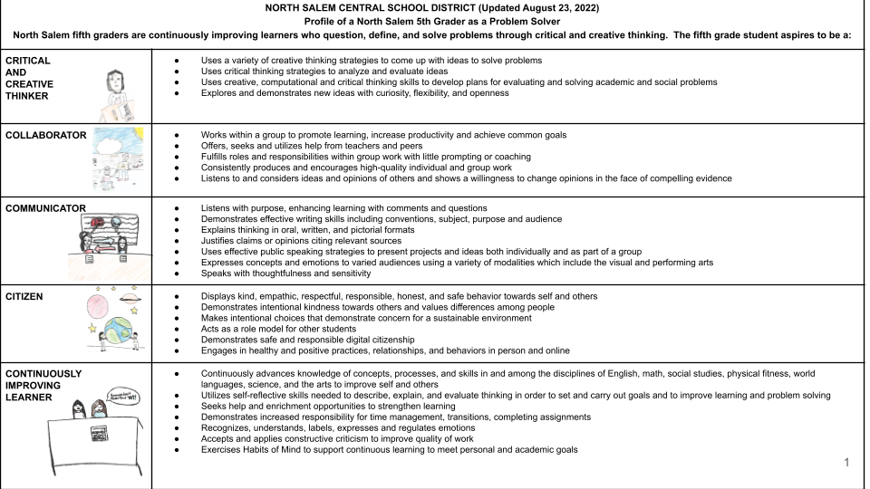

The Profile of a North Salem Graduate builds upon the work on the Profile of a North Salem 5th Grader. Students are expected to actively engage in achieving the indicators described in the Profile of a North Salem Graduate. Teachers and staff provide learning experiences in and outside of the classroom for students at North Salem Middle School/High School which challenge and prepare students so that once they graduate, students will have experienced these indicators multiple times and they can confidently embody these practices and dispositions. Professional development is intentionally designed to support teachers and staff as they work towards achieving the Profile of a North Salem Graduate with our students.

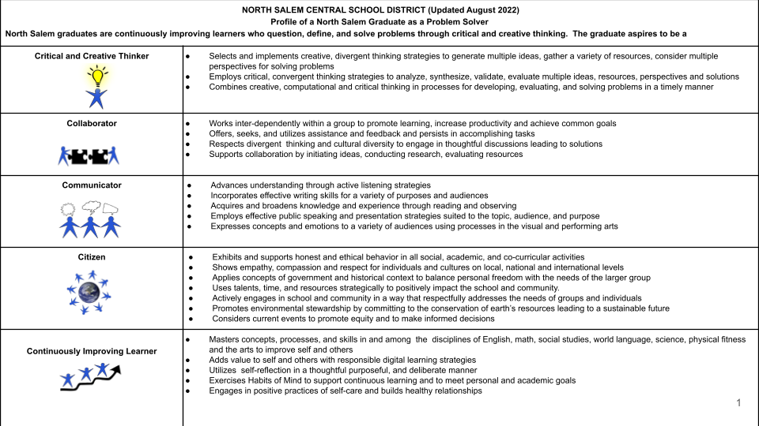

# 

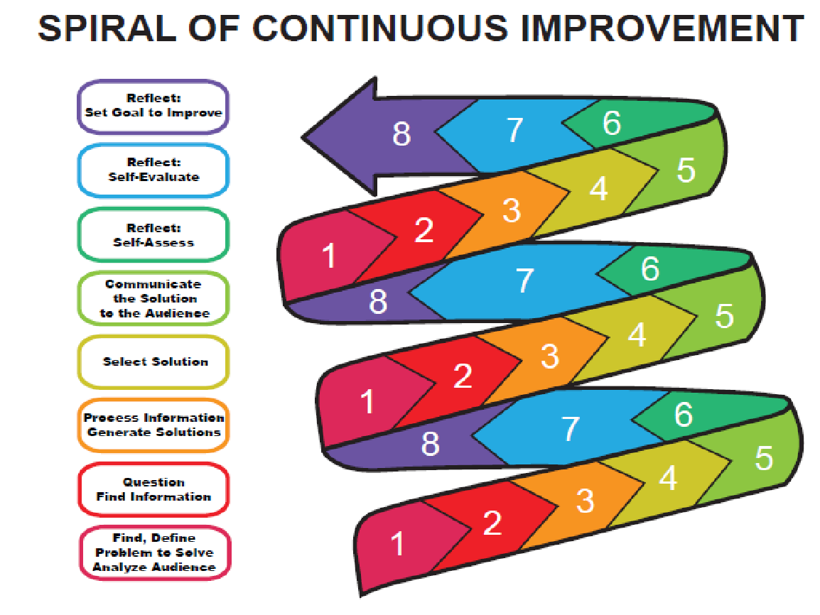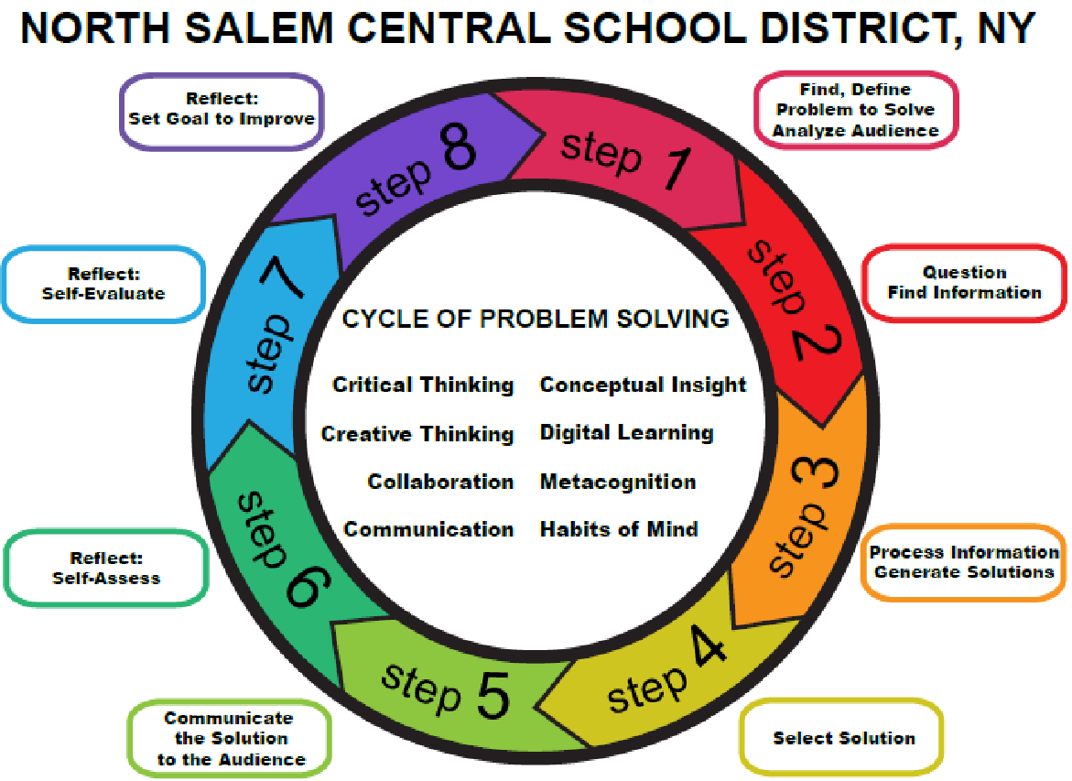

The North Salem Problem Solving Cycle and the Spiral of Continuous Improvement further serve to operationalize our District’s Mission and these schematics provide our students, faculty and staff with a common language and an effective approach to problem solving, design thinking, reflective practice and continuous improvement.

# Professional Learning Principles

This plan incorporates the following researched-based principles to guide the professional learning process.

Professional learning will align with the District’s Master strategies and indicators of success focused on improving instruction and students’ learning so that students may effectively solve problems through critical and creative thinking.

* require a continuous cycle of learning, application, and reflection.
* encourage professional collaboration.
* be designed to build a climate for growth and success.
* be supported by adequate resources; time and funding are necessary for quality professional learning.
* be based on analyses of the differences between actual student performance and goals and standards for student learning.
* prepare educators to demonstrate high expectations for student learning.
* be continuous and on-going, involving follow-up and support for further learning, including support from sources external to the school that can provide necessary resources and new perspectives.
* concomitantly achieve district objectives and provide voice, choice and teacher/staff member agency in the identification of what they need to learn and in the development of the learning experiences in which they will be involved.
* use a variety of approaches and opportunities to accomplish the goals of improving instruction and student success.
* be research based and provide opportunities to gain an understanding of the theory underlying the knowledge and skills being learned.
* promote reflective and responsive practice that demonstrates adjustments are made on a continuing basis to improve the effectiveness of instruction and assessment.
* be all inclusive; teachers (including part-time and long-term substitutes), teaching assistants, and all other staff members will participate in professional learning.

# NYS Professional Learning Standards & Indicators

The NYS Professional learning standards along with the [Tri State Consoritium’s Professional Learning Rubric](https://drive.google.com/file/d/1nAXfuV8maqqVmqgYv_-uAvCrGagNSKrf/view?usp=sharing) serve as guidelines for North Salem’s professional learning plan.

**Standard 1: Designing Professional Development**

**Standard:**

Professional learning design is based on data, is derived from the experience, expertise and needs of the recipients, reflects best practices in sustained job-embedded learning, and incorporates knowledge of how adults learn.

**Indicators:**

1a. Professional learning design begins with a needs assessment that is grounded in the analysis of multiple sources of disaggregated teaching and learning data.

1b. Professional learning design is based on the learning styles of adult learners as well as the diverse cultural, linguistic, and experiential resources that they bring to the professional learning activity.

1c. Professional learning design is grounded in the New York State Learning Standards and student learning goals.

1d. The intended beneficiaries of professional learning are substantially involved in all aspects of professional learning design.

1e. Professional learning design addresses the continuum of an educator’s experience and level of expertise, and is based on an analysis of individual educator needs; current knowledge and skills; and district, building and educator learning goals.

1f. Professional learning formats include, but are not limited to, lesson study, demonstrations, observations, analysis of student work and assessment data, collegial circles, feedback, action research, reflection, and opportunities for collaboration and problem solving.

1g. The format of professional learning incorporates technologies to provide more extensive and diverse content, expand access and participation, and create virtual professional learning communities.

1h. Professional learning is sustained over time and provides continued support such as follow-up, demonstrations, feedback on mastery of new knowledge and skills, peer coaching and mentoring, and continued opportunities for additional study.

**Standard 2: Content Knowledge and Quality Teaching**

**Standard:**

Professional learning expands all educators’ content knowledge and the knowledge and skills necessary to provide developmentally appropriate instructional strategies and assess student progress.

**Indicators:**

2a. Professional learning includes learning experiences and resources to ensure that educators understand how the subjects they teach address the New York State Learning Standards and the relationships between the subjects they teach and the other subjects in the curriculum.

2b. Professional learning provides opportunities for educators to examine, observe, practice, and receive feedback on their use of research-based instructional strategies to improve their students’ learning by utilizing methods such as peer review, coaching, mentoring, and modeling.

2c. Professional learning provides ongoing opportunities for educators to examine a variety of classroom assessments, practice using them in their classrooms, and analyze the results to 1) understand and report on student achievement based on New York State Learning Standards, 2) identify gaps in student learning, and 3) adjust instruction.

2d. Professional learning provides differentiated instructional strategies to meet the needs of diverse learners.

2e. Professional learning ensures that educators have the knowledge and skills needed to develop and foster the critical thinking, problem solving, literacy, and technological skills that students need to be successful in the 21st century.

2f. Professional learning provides the knowledge, skill, and opportunity for educators to make relevant connections between the subjects they teach and the applications of those subjects.

**Standard 3: Research-based Professional Learning**

**Standard:**

Professional learning is research-based and provides educators with opportunities to analyze, apply, and engage in research.

**Indicators:**

3a. Professional learning is based on current research in teaching, learning, and leadership.

3b. Effective professional learning ensures that all educators have the knowledge, skill, and opportunity to apply research to instructional decision making.

3b.1. Professional learning includes ongoing opportunities for educators to read and reflect on current research on topics that are of interest to them and that are consistent with state and local school improvement priorities.

3b.2. Professional learning involves discussion of research design, data collection, and analysis to assist teachers in understanding how to interpret research findings, particularly in areas where there may be competing perspectives and conclusions.

3b.3. Professional learning provides opportunities for educators to collaborate with higher education and other partners in action research to test their own hypotheses and to report the results about the impact of professional learning programs or the effectiveness of particular instructional strategies and programs for educators and students.

**Standard 4: Collaboration**

**Standard:**

Professional learning ensures that educators have the knowledge, skill, and opportunity to collaborate to improve instruction and student achievement in a respectful and trusting environment.

**Indicators:**

4a. Professional learning provides skills that educators need to communicate effectively, to listen to the ideas of others, to exchange and discuss ideas, to work in diverse teams, and to share responsibility for work toward a common goal.

4b. Professional learning provides ongoing opportunities for educators to work with colleagues including teachers, principals, teaching assistants, librarians, counselors, social workers, psychologists, higher education faculty, and others critical to student success.

4c. Professional learning maximizes the use of technology to broaden the scope of collaboration.

**Standard 5: Diverse Learning**

**Standard:**

Professional learning ensures that educators have the knowledge and skill to meet the diverse needs of all students.

**Indicators:**

5a. Professional learning focuses on developing educators’ knowledge of the learning styles, needs, and abilities of their students, as well as the diverse cultural, linguistic, and experiential resources that their students bring to the classroom.

5b. Professional learning provides opportunities for educators to develop the knowledge and skills necessary to design and implement differentiated instructional and assessment strategies that utilize diverse student, family and community resources, and that meet diverse student learning needs.

5c. Professional learning provides opportunities for educators to examine their practice in setting and maintaining high expectations for all students to enable them to attain high levels of achievement.

**Standard 6: Student Learning Environments**

**Standard:**

Professional learning ensures that educators have the knowledge and skill to create safe, secure, supportive, and equitable learning environments for all students.

**Indicators:**

6a. Professional learning provides opportunities for educators to create a safe, inclusive, equitable learning community where everyone participates in maintaining a climate of caring, respect, and high achievement.

6b. Professional learning provides opportunities for educators to collaborate with school psychologists and social workers to develop effective strategies for student behavior and classroom management, and to seek creative solutions to conflicts.

6c. Professional learning provides opportunities for educators to analyze and use data about student behavior (such as discipline referrals, suspension information, school climate surveys, and social-emotional data) to refine educational practices and promote optimal learning environments.

**Standard 7: Parent, Family and Community Engagement**

**Standard:**

Professional learning ensures that educators have the knowledge, skills, and opportunity to engage and collaborate with parents, families, and other community members as active partners in children’s education.

**Indicators:**

7a. Professional learning provides opportunities for educators to develop communication and collaboration skills that enable them to build partnerships with parents, guardians, and the community.

7b. Professional learning enhances educators’ knowledge of varying cultural backgrounds of students, families, and the community, and of how the diversity of these cultural backgrounds can serve as foundations and resources for student learning and success.

7c. Professional learning includes opportunities for educators to develop skills and strategies that use technology to strengthen partnerships with parents, families, and the community.

**Standard 8: Data-driven Professional Practice**

**Standard**:

Professional learning uses disaggregated student data and other evidence of student learning to determine professional learning learning needs and priorities, to monitor student progress, and to help sustain continuous professional growth.

**Indicators:**

8a. Professional learning ensures ongoing opportunities for all educators to learn how to analyze and collect multiple sources of student data throughout the year, to monitor student progress and adjust instructional practice.

8b. Professional learning provides educators with the opportunity to examine all relevant student data, including Individual Education Plans (IEPs), at the beginning and throughout the academic school year, in order to design effective instruction.

8c. Professional learning provides educators with current, high quality data analysis presented in a clear, understandable format, to promote optimal student learning.

8d. Professional learning provides opportunities for educators to use results from local, state and national assessments; student work samples and portfolios; school climate, parent, and teacher surveys; and student behavior data to guide their instruction.

8e. Professional learning provides ongoing opportunities for educators to use disaggregated student data by race, gender, English language learning, special needs, eligibility for free or reduced price meals, and other factors in order to improve student learning.

**Standard 9: Technology**

**Standard:**

Professional learning promotes technological literacy and facilitates the effective use of all appropriate technology.

**Indicators:**

9a. Professional learning ensures ongoing educator and student technological literacy.

9b. Professional learning provides ongoing opportunities for educators to learn about new and emerging technologies useful in professional teaching practice.

9c. Professional learning facilitates the ability of educators to apply technologies to create optimal and equitable learning environments.

9d. Professional learning promotes technology as a tool to design learning opportunities, to evaluate the effectiveness of instruction, and to monitor student learning.

9e. Professional learning encourages educators to engage with students in using available technology as it relates to curricular activities, and to assist students in using technology in innovative ways.

9f. Professional learning provides educators with opportunities to learn and use technology for communication and collaboration.

9g. Professional learning addresses the legal and ethical uses of technology.

**Standard 10: Evaluation**

**Standard:**

Professional learning is evaluated using multiple sources of information to assess its effectiveness in improving professional practice and student learning.

**Indicators:**

10a. Resources are provided to plan and conduct ongoing evaluation of professional learning.

10b. Professional learning evaluation uses multiple measures to assess effectiveness of the knowledge and skill acquired in improving professional practice and student learning (such as the use of new learning in instructional planning, the use of student data for the development and adaptation of teaching strategies, or the enhanced student performance following the application of a different teaching strategy).

10c. Professional learning evaluation includes the use of multiple methods and techniques that provide information to ensure ongoing improvements in the quality of the professional learning experience (such as participant reactions, surveys, focus groups, interviews, reflective journals, portfolios, or information about student behavior or performance).

10d. Professional learning evaluation results are reported to key stakeholder groups in a manner that promotes effective use of the evaluation data for improving both individual educator practice and building- and district-wide professional learning plans.

# 

# Triangulation of Data Sources

A successful professional learning program is designed based on quantitative data and qualitative data. In order to accomplish this tenet, North Salem Central School District uses multiple data sources to inform its decision making around professional learning. The following are examples of the various types quantitative and qualitative data sources used:

**District Committees**

**Administrative Council**

**Instructional Lead Teachers & Department Chairs**

**North Salem Teachers’ Association**

**North Salem Administrators’ Association**

**Board of Education**

**NYS School Report Cards**

**New York State Learning Standards**

**Common Core Learning Standards**

**BEDS Data**

**Student Performance Results**

**State Assessment Results**

**Local Assessment Results**

**Professional Learning Survey Results**

**Learning Walks**

# Professional Learning Opportunities & Requirements Continuing Teacher and Leader Education (CTLE) Attainment

In order to meet the diverse learning needs of teachers and staff members in the North Salem Central School District, a wide variety of opportunities are used to provide professional learning experiences. All teachers and staff members regardless of the expectation to meet CTLE requirements are continuously encouraged to explore different learning means in order to facilitate their professional learning on a yearly basis.

North Salem is a provider of Continuing Teacher and Leader Education (CTLE) programs. Educators who hold one or more of the following certificates are subject to the continuing teacher and leader education (CTLE) requirement:

* Professional certificate in the classroom teaching service
* Professional certificate in the educational leadership service (i.e., School Building Leader, School District Leader, and School District Business Leader)
* Teaching Assistant Level III certificate

Examples of educators who do not need to complete the CTLE requirement include, but are not limited to, educators who:

* Hold only Permanent certificate(s)
* Hold a Statement of Continued Eligibility (SOCE) and Permanent certificate, and does not also hold a Professional or TA Level III certificate; and
* Have "Registered - Inactive" status (e.g., not practicing in an applicable school).

The registration and CTLE requirements do not apply to educators who hold a certificate in the pupil personnel service (e.g., School Attendance Teacher, School Counselor, School Psychologist, School Social Worker) or hold a Teaching Assistant Level I or Level II certificate.

There is one CTLE requirement per educator (e.g., 100 clock hours), regardless of the number of certificates held that are subject to CTLE. Educators who are subject to CTLE and practice in an applicable school throughout their five-year registration period must complete 100 clock hours of acceptable CTLE.

The following table describes the number of clock hours of CTLE required for educators, depending on their situation.

|  |  |  |
| --- | --- | --- |
| Total number of CTLE clock hours for the registration period | No inactive periods during the registration period | Inactive during part of the registration period |
| Holds a Professional teacher or educational leader certificate or Teaching Assistant Level III certificate for the entire registration period | Complete 100 clock hours | Complete 20 clock hours for every year in which you were practicing in an applicable school |
| Originally held only Permanent certificate(s) and then obtains a subsequent Professional certificate during the registration period | Complete 20 clock hours for every year in which you were practicing in an applicable school while holding a Professional or Teaching Assistant Level III certificate | Complete 20 clock hours for every year in which you were practicing in an applicable school while holding a Professional or Teaching Assistant Level III certificate |
| Hold only Permanent certificate(s) for the entire registration period | Not subject to CTLE | Not subject to CTLE |

The definitions of an “[applicable school](http://www.highered.nysed.gov/tcert/resteachers/ctle-applicable-sch.html)” and “practicing” are provided below:

* “Applicable schools” include New York State (NYS) school districts or BOCES. NYS nonpublic schools also became applicable schools on October 17, 2017. In addition, the New York City Department of Education and any of its components are considered a single applicable school.
* “Practicing” means employed 90 days or more during a school year by a single applicable school in New York State. A day of employment includes a day actually worked in whole or in part, or a day not actually worked but a day paid.

**Calculating CTLE Clock Hours**

Educators who are [subject to CTLE](http://www.highered.nysed.gov/tcert/resteachers/ctle.html) and practice in an applicable school throughout their five-year registration period must complete 100 clock hours of acceptable CTLE.

Educators who are subject to CTLE and have inactive periods during their registration period would complete less than 100 clock hours. They would complete a minimum of 20 clock hours of CTLE for every year of the registration period they were practicing in an applicable school. The rate of 20 clock hours of CTLE per year will not be prorated for a period of less than one year. In addition, educators who hold only Permanent certificate(s) for part of the registration period, and then obtain a subsequent Professional certificate during the registration period, would complete a minimum of 20 clock hours of CTLE for every year that they were practicing in an applicable school while holding the Professional certificate.

Some examples of how to calculate the number of CTLE clock hours are provided below.

* A teacher holds a Professional certificate and practices for three years in an applicable school. Then, they practice for two years in a non-applicable school. Therefore, they need to complete 3 x 20 = 60 total CTLE clock hours during their five-year registration period.
* A teacher initially registered under their Permanent teacher certificate and practiced for three years under this certificate. They subsequently earned a Professional certificate and practiced in an applicable school, either as a teacher or principal, for two years. Therefore, they need to complete 2 x 20 = 40 total CTLE clock hours during their five-year registration period.

**When Educators Can Complete CTLE Hours**

Educators can complete CTLE clock hours any time during the registration period. CTLE clock hours completed prior to registration or during a prior registration period may not be carried over to the current registration period. Professional development or professional learning not designated as CTLE by an approved sponsor does not count towards the required CTLE clock hours.

Teachers and staff who fall under the obligation of meeting NYSED’s CTLE requirements, please see the following links:

* [Approved CTLE Sponsors](http://www.highered.nysed.gov/tcert/resteachers/ctlesponsors.html)
* [Registration and CTLE Requirements Chart](http://www.highered.nysed.gov/tcert/pdf/registrationtable.pdf)
* [Number of CTLE Clock Hours](http://www.highered.nysed.gov/tcert/resteachers/ctle-hours)
* [Acceptable CTLE Activities](http://www.highered.nysed.gov/tcert/resteachers/ctle-acceptable.html)
* [CTLE Language Acquisition Requirement](http://www.highered.nysed.gov/tcert/resteachers/ctle-language-acquisition.html)
* [CTLE Recordkeeping and Documentation](http://www.highered.nysed.gov/tcert/resteachers/ctle-record-doc.html)
* [Registration Overview](http://www.highered.nysed.gov/tcert/resteachers/registration-new.html)
* [Registration and CTLE Contact Information](http://www.highered.nysed.gov/tcert/resteachers/registration-contact)

Teachers and staff who are fall under CTLE requirements must maintain a record of completed CTLE, which shall include: the title of the program, the total number of hours completed, the number of hours completed in language acquisition addressing the need of English language learners, the sponsor's name and any identifying number, attendance verification, and the date and location of the program. Such records shall be retained for at least three years from the end of the registration period in which the continuing teacher and leader education was completed and shall be available for review by the department upon request.

#### CTLE Language Acquisition Requirement

The continuing teacher and leader education (CTLE) language acquisition requirement varies by certificate holder.

* **ESOL and bilingual education teachers.** Educators who are subject to CTLE, and hold a Professional English to Speakers of Other Languages (ESOL) certificate or Bilingual Education extension, must complete a minimum of 50 percent of their required CTLE clock hours in language acquisition aligned with the core content area of instruction taught, including a focus on best practices for co-teaching strategies, and integrating language and content instruction for ELLs.
* **Other teachers, school building leaders, and school district leaders.** All other Professional teacher, School Building Leader, and School District Leader certificate holders must complete a minimum of 15 percent of the required CTLE clock hours dedicated to language acquisition addressing the needs of ELLs, including a focus on best practices for co-teaching strategies and integrating language and content instruction for ELLs.
* **School district business leaders.** School district business leaders (SDBLs) who hold the Professional SDBL certificate would complete a minimum of 15 percent of the required CTLE clock hours dedicated to the needs of ELLs and Federal, State, and local mandates for ELLs.
* **Teaching Assistants - Level III.** Teaching Assistant Level III certificate holders must complete a minimum of 15 percent of the required CTLE clock hours dedicated to language acquisition, addressing the needs of ELLs and integrating language and content instruction for such ELLs.

A table showing the CTLE language acquisition requirement for each certificate holder, including when an exemption may apply, is available [here](http://www.highered.nysed.gov/tcert/pdf/languageacquisitiontable.pdf).

**Exemption**

School districts can seek an exemption for the CTLE language acquisition requirement if they have fewer than 30 English Language Learners (ELLs) enrolled, or ELLs comprise less than 5% of the district's total student population, as of a date established by the [Office of Bilingual Education and World Languages](http://www.nysed.gov/bilingual-ed/forms-and-waivers). For the exemption, the school district would complete and submit the [professional development waiver online form](https://forms.office.com/Pages/ResponsePage.aspx?id=6BbvFeBMw0-S4mp6bI52XhzNxVUvjbZImYfHcnATVCtUM0ZYT0dZUTc1Sk5YT1I1WTg3V1JGODJROCQlQCN0PWcu).

Educators who are subject to CTLE are exempt from the CTLE language acquisition requirement for each year they practice in an applicable school with an approved exemption for the CTLE language acquisition requirement. The school district, rather than the educator, would obtain the exemption. **Educators who are employed by an applicable school with an approved CTLE language acquisition requirement exemption still must complete the CTLE requirement (e.g., 100 clock hours).**

|  |
| --- |
| **Examples of Activities to Meet the**  **CTLE Language Acquisition Requirement** |
| **Best Practices**   * Best practices for Bilingual Education (Dual Language and Transitional programs) * Best practices for English as a New Language (ENL) * Academic language and English Language Learners (ELLs)/Multilingual Learners (MLLs) * Co-teaching strategies, structures and supports * Effective literacy strategies for ELLs/MLLs * Scaffolds that support ELLs/MLLs in mastering core content * Home Language and literacy development * Aligning instructional resources to meet the needs of ELLs/MLLs * Lesson Planning using the Targets of Measurement (TOMs), Performance Level Descriptors (PLDs), and the Bilingual Common Core Progressions |
| **Identification, Placement, Assessment**   * Identification procedures for ELLs/MLLs * Response to Intervention (RtI) for ELLs/MLLs * Identification and placement procedures for ELLs/MLLs * Assigning credits and reviewing international transcripts * Appropriate assessment procedures/approaches to ELL/MLL assessment * Language Learning vs. Disability |
| **IEPs, Instruction, Students with Disabilities**   * Integrating language and content instruction for ELLs/MLLs * Meeting the needs of subpopulations of ELLs/MLLs (e.g., Students with Interrupted/Inconsistent Formal Education, ELLs/Students with Disabilities, Newcomers, Developing ELLs, Long Term ELLs, Former ELLs) * Bridges training for Low Literacy SIFE * Bilingual Common Core Progressions * Best practices for working with ELLs/MLLs with an IEP * Gifted and Talented ELLs/MLLs |
| **Home, Family, Community, Culture, and Social**   * Home language and literacy development in Bilingual Education programs * Strengthening home/school communication * Cultural responsiveness or cultural competency training for teachers and administrators * Best practices on how to support and sustain ELLs’/MLLs’ social and emotional development needs, including creating a safe and supportive environment that is conducive to learning * Supporting and strengthening family and community engagement * Cultivating a multilingual school environment * Using the home language to accelerate English Language Development |

**Please note that new staff orientation or workshops mandated for NYSED educator certification) do not qualify as acceptable CTLE. CTLE has to be in the content area of the educator’s certificate, in pedagogy, or in language acquisition for English language learners.**

80-6.9 Acceptable continuing teacher and leader education.

(a) Acceptable CTLE must be taken from a sponsor approved by the department pursuant to section 80-6.10 of this Subpart.

(b) **Acceptable CTLE shall be studied in the content area of any certificate title held by the individual or in pedagogy, and include any required study in language acquisition addressing the needs of English language learners as described in section 80-6.3 of this Subpart. Acceptable CTLE must be conducted through activities designed to improve the teacher or leader’s pedagogical and/or leadership skills, targeted at improving student performance, including but not limited to formal CTLE activities. Such activities also shall promote the professionalization of teaching and educational leadership, as applicable, and be closely aligned to district goals for student performance.**

8 CRR-NY 80-6.9

Effective December 31, 2019 (not retroactive), Educators acting as a mentor to a new classroom teacher as part of a school district’s or BOCES’ mentoring program may, at the discretion of the school district or BOCES, credit up to 30 hours of such time towards their CTLE requirement in each five-year registration period. Educators acting as a mentor to a teacher candidate may, at the discretion of the school district or BOCES, credit up to 25 hours of such time towards their CTLE requirement in each five-year registration period. North Salem Central School District currently provides pay for mentorship and not CTLE.

*The following is a list of examples of different ways in which staff members access professional learning in North Salem Central School District and may be able to obtain CTLE credits if the workshops/conferences attended are focusing on the content area of the educator’s certificate, in pedagogy or in language acquisition for English language learners in order to be considered acceptable CTLE. If an acceptable CTLE activity is completed during a meeting or conference, CTLE hours will be issued specifically for that activity and not merely for attending a meeting or conference:*

Workshops and conferences - attendance and turnkeyed information (if it complies with Subpart 80-6 of the Commissioner’s Regulations)

All Points Applied Behavioral Analysis

Global Compliance Network Training

Lower Hudson Regional Information Center

Tri State Consortium

Teacher visitations to other classrooms/schools

Hudson River Teacher Center courses

Putnam Northern Westchester BOCES Catalog of Courses

Southern Westchester BOCES Catalog of Courses

Hudson Valley Regional Bilingual Education Resource Network

Harvard Graduate School of Education Online Courses

EduPlanet Habits of Mind Courses

NYSUT courses

In-district consultants

Action research and/or collegial circles

Reading lists and facilitated discussions related to educational literature

Professional Learning Days

Resource material distribution

Release periods/days

Summer workshops and curriculum development days

Data analysis of student work

Infusion of professional learning into faculty, team, grade level and department meetings

**Superintendent Conference Days and Professional Development Days**

The District designs the content of the superintendent conference days in collaboration with faculty and the administrators to ensure meaningful collaboration and learning. These days, scheduled throughout the year, include a focus on curriculum, instruction, and assessments, social-emotional learning, data review, and other District, building and departmental priorities established from feedback from all stakeholders. Teachers are also provided with choice on professional learning opportunities that align to the District’s Mission. It is essential that the learning that faculty and staff selects is applied to their practice and reflected upon for continuous improvement. Credit for CTLE will be provided for individuals if the session is in the content area of the educator’s certificate, is centered on pedagogy, or in language acquisition for English language learners in order to be acceptable CTLE.

**Monthly Faculty, Grade Level and Department Meetings**

The monthly faculty meetings and the grade level or department meetings in each building are designed to engage teachers in ongoing reflective dialogue focused on District, building and department needs. To this end, administrators design these meetings based on building and departmental goals and needs that arise from faculty input and District priorities. It is essential that the learning that faculty and staff selects is applied to their practice and reflected upon for continuous improvement. Credit for CTLE will be provided for individuals if the session is in the content area of the educator’s certificate, is centered on pedagogy, or in language acquisition for English language learners in order to be acceptable CTLE.

**Support Staff Training**

The District recognizes the important role of the support staff throughout the District. The support staff, including paraprofessionals, are provided professional learning opportunities in the summer and during the school year. The training is designed to support the curricular and instructional needs of teachers and the operational needs in the buildings. The District seeks input from support staff in designing the professional learning activities. It is essential that the learning that faculty and staff selects is applied to their practice and reflected upon for continuous improvement. Credit for CTLE will be provided for individuals if the session is in the content area of the educator’s certificate, is centered on pedagogy, or in language acquisition for English language learners in order to be acceptable CTLE.

**Tri State Consortium**

The Tri-State Consortium is a dynamic learning organization of public school districts that values systems thinking as the foundation for continuous improvement. The Consortium assists its member districts in using quantitative and qualitative data to enhance student performance and to build a rigorous framework for planning, assessment, and systemic change. Collaborating as colleagues and critical friends, Consortium members apply the standards of the Tri-State model to benchmark member districts' progress in advancing teaching and learning. North Salem takes advantage of the many opportunities offered through the Consortium, including: critical friends, teacher training and District visits; study groups for superintendents, curriculum leaders, and principals; annual conferences; and the Performance Assessment Design Initiative.Credit for CTLE will be provided for individuals if the session is in the content area of the educator’s certificate, is centered on pedagogy, or in language acquisition for English language learners in order to be acceptable CTLE.

**Putnam/Northern Westchester BOCES**

Through our participation in the Putnam/Northern Westchester BOCES Curriculum Council, administrators and faculty are afforded numerous opportunities for information and training on all state initiatives as well as training for all state assessments. In addition, participation in Putnam/Northern Westchester BOCES affords North Salem opportunities to participate in numerous regional initiatives. Some examples include:

* Curriculum development and instructional strategies to support the New York State Learning Standards and other NYS standards initiatives
* STEAM and technology initiatives
* Integrated ELA/Social studies curriculum K-5
* Social-emotional learning

Access to regional and national consultants is available to North Salem’s administrators through participation in the BOCES Curriculum Council. These consultants are selected to support District and building goals and best practices. Directors, Coordinators, Department Chairs and Instructional Lead Teachers are afforded the opportunity to participate in regional chairpersons meetings to remain current on state initiatives. It is essential that the learning that faculty and staff selects is applied to their practice and reflected upon for continuous improvement. Credit for CTLE will be provided for individuals if the session is in the content area of the educator’s certificate, is centered on pedagogy, or in language acquisition for English language learners in order to be acceptable CTLE.

**Southern Westchester BOCES**

North Salem’s teachers and administrators will be afforded the opportunity to participate in Southern Westchester BOCES’ professional learning offerings as approved by the Superintendent. Access to regional and national consultants is available to North Salem’s administrators through participation in the BOCES Curriculum Council. It is essential that the learning that faculty and staff selects is applied to their practice and reflected upon for continuous improvement. Credit for CTLE will be provided for individuals if the session is in the content area of the educator’s certificate, is centered on pedagogy, or in language acquisition for English language learners in order to be acceptable CTLE.

**Summer Curriculum Work**

The North Salem Central School District curriculum budget has provided funds for summer curriculum work. Projects for summer curriculum work are developed by principals, assistant principals, coordinators and directors in collaboration with faculty. Each year, specific goals are developed through the framework of the Administrative Goals aligned to Board of Education and District goals. Administrators determine specific needs for each summer’s curriculum work. CTLE will not be awarded for summer curriculum work.

**Consultant Support**

Each year, North Salem identifies specific goals and expert consultants to support specific needs of the faculty to meet high expectations for our students. Consultants from both within the regional networks and outside the networks are utilized. A current list of consultants can be found in the Professional Learning Best Practices section as well as on page 31. It is essential that the learning that faculty and staff engage in is applied to their practice and reflected upon for continuous improvement. Work with consultants may be awarded CTLE Credit if the session is in the content area of the educator’s certificate, is centered on pedagogy, or in language acquisition for English language learners in order to be acceptable CTLE.

**North Salem CSD CTLE Sponsor Documentation**

North Salem CSD and Approved CTLE sponsors will maintain records of the CTLE awarded for eight years. North Salem CSD will exclusively use NYSED’s Completion of Approved Continuing Teacher and Leader Education (CTLE) Hour(s) Certificate. Please access the link below:

* The [Completion of Approved CTLE Hour(s) Certificate](http://www.highered.nysed.gov/tcert/pdf/ctle-certificate-completion-form.pdf)

# 

# 

# 

# 

# 

# 

# 

# 

# 

# 

# 

# Professional Learning Best Practices

|  |  |  |
| --- | --- | --- |
| **Best Practice** | **Description** | **Provider** |
| Habits of Mind | All district teachers and staff will engage in Habits of the Mind training and implementation. The Habits of Mind are an identified set of 16 problem solving, life related skills, necessary to effectively operate in society and promote strategic reasoning, insightfulness, perseverance, creativity and craftsmanship. | District Staff; Hudson River Teacher Center |
| Visible Thinking Routines | All teachers and staff will engage in visible thinking routine learning and implementation. A thinking routine is **a short series of steps that guides your thought process**. They're simple and easy to use. Best of all, encouraging students to use them regularly will lead to them growing in confidence, improving critical thinking, and more open discussions | District Staff; Harvard Graduate School of Education Online Courses |
| Computational Thinking | All teachers and administrators will engage in computational thinking, learning and implementation. Computational thinking **allows us to take a complex problem, understand what the problem is and develop possible solutions**. We can then present these solutions in a way that a computer, a human, or both, can understand. | District Staff; Digital Promise; PNW BOCES |
| Yale RULER | All teachers and staff will engage in RULER learning and implementation. RULER is **an acronym for the five skills of emotional intelligence**: Recognizing emotions in oneself and others. Understanding the causes and consequences of emotions. Labeling emotions with a nuanced vocabulary. Expressing emotions in accordance with cultural norms and social context. RULER is **a systemic approach to SEL developed at the Center for Emotional Intelligence**. RULER aims to infuse the principles of emotional intelligence into the entire system of preK to 12 schools, informing how leaders lead, teachers teach, students learn, and families support students. | District Staff; Yale Center for Emotional Intelligence; PNW BOCES |
| Differentiated Instruction Made Practical | All teachers and staff will engage in Differentiated Instruction Made Practical learning and implementation. Differentiated Instruction Made Practical builds educators' abilities to differentiate instruction as a part of their daily classroom routines, whether online or in-person. By using a four-step teacher decision-making framework and implementing structured classroom routines rooted in research on cognition and motivation, teachers increase equity, access, rigor, and engagement for all students. Differentiated instruction made practical equips teachers/staff with the agile thinking required to analyze problems of student learning and then make decisions to adjust and differentiate instruction within the given time and curriculum constraints. | District Staff; Harvard Graduate School of Education online course; Hudson River Teacher Center |
| North Salem Learning Principles | All teachers and administration will engage in learning and implementation of the North Salem Learning Principles. Learning principles serve as a way to translate curriculum  into meaningful learning that will meet the intention of  North Salem Mission: *Engage students to continuously*  *learn, question, define and solve problems through critical*  *and creative thinking.* These curated learning principles  are based on research of what constitutes best practice  whether in person or remote. They continue to remind us  of what needs to be at the forefront of our planning,  instruction, and assessment design to motivate active and meaningful engagement in learning. | District Staff |
| Diversity, Equity and Inclusion- Culturally Responsive and Sustaining Framework | All teachers and staff will engage in learning and implementing the Culturally Responsive and Sustaining Framework and additional DEI workshops.  [The Culturally Responsive-Sustaining (CR-S) Education Framework](http://www.nysed.gov/common/nysed/files/programs/crs/culturally-responsive-sustaining-education-framework.pdf) is intended to help education stakeholders create student-centered learning environments that affirm cultural identities; foster positive academic outcomes; develop students’ abilities to connect across lines of difference; elevate historically marginalized voices; empower students as agents of social change; and contribute to individual student engagement, learning, growth, and achievement through the cultivation of critical thinking. The framework was designed to support education stakeholders in developing and implementing policies that educate all students effectively and equitably, as well as provide appropriate supports and services to promote positive student outcomes.  The framework is grounded in four principles:   * Welcoming and Affirming Environment * High Expectations and Rigorous Instruction * Inclusive Curriculum and Assessment * Ongoing Professional Learning | District Staff; PNW BOCES; SW BOCES |

* The PD Master Plan Outlines the Philosophy and General Operating Procedures for PD in the North Salem Central School District.
* Each year, the North Salem Professional Development Team will collaborate with the Staff and with the Administration to create the details of the Professional Development Plan to improve student performance that year.
* It is essential that the learning that faculty and staff selects is applied to their practice and reflected upon for continuous improvement.

1. PURPOSES OF PROFESSIONAL DEVELOPMENT
2. The purpose of professional development is to sustain a systematic approach to increasing the capacity of all staff to contribute to the significant improvement of the performance of all students according to the North Salem Central School District measurable goals for student performance. Please refer to page 6 for an overview of our professional learning principles.
3. Staff development will support the development of new teachers and the continuous improvement of all staff.
4. THE SCOPE OF STUDENT PERFORMANCE ADDRESSED BY PROFESSIONAL DEVELOPMENT
5. Student performance includes academic, interpersonal and intrapersonal competencies.
6. The graphics titled The Profile of a North Salem Graduate and the Profile of a North Salem 5th Grader, the Problem Solving Cycle, and the Spiral of Continuous Improvement provide a framework for the systematic development of goals for student performance.
7. PROFESSIONAL DEVELOPMENT CONNECTIONS TO STANDARDS FOR STUDENT PERFORMANCE
8. The planning, implementation and evaluation process for professional development district-wide emphasizes a high degree of congruence with student needs as identified by classroom and district data from multiple sources (Refer to page 13).
9. The specific professional development priorities and activities for each year will be strongly based on the data from the assessment and evaluation of student performance relevant to the goals for student performance.
10. Professional development is a process that supports and connects all components of the educational system.
11. Professional development must have a systematic, systemic and sustained focus on improving the performance of all students.
12. THE CONTENT OF PROFESSIONAL DEVELOPMENT ACTIVITIES
13. Professional development will emphasize job-specific content and skills and interpersonal and intra-personal skills.
14. Professional development will include training in school violence prevention and intervention, and DASA.
15. Mentor program will be provided to all new teachers to the district or teachers moving from one grade level to another or teachers moving into a new assignment in order to provide support for new teachers in the classroom teaching service in order to ease the transition from teacher preparation to practice, thereby increasing retention of teachers, and to increase the skills of new teachers in order to improve student achievement in accordance with the State learning standards.
    1. Mentor positions will be posted district wide and mentors will apply to the building principals and the principals send the recommendations to Human Resources.
    2. Mentors work with their mentees for a year and have regular meetings to support their mentees. Their hours are logged and submitted to Human Resources.
    3. Mentoring is compensated.
16. New Teachers will be provided with an additional day of training after school on the Danielson Framework, technology, the creation of Problem Solving Tasks, students with disabilities, English Language Learners, as well as obtaining feedback on their own learning needs and providing them with resources.
17. Professional development will include ongoing training for all staff on the District’s Mission and Mission-related initiatives including but not limited to North Salem Best Practices which include: North Salem Learning Principles and Differentiation; Equity, Diversity and Inclusion- Culturally Responsive Teaching; Computational Thinking, SEL, Health and Safety, Visible Thinking Routines, Habits of Mind, Yale RULER, Problem Solving Tasks, Profile of a North Salem Graduate, Profile of a North Salem 5th Grader and use of 4Cs Rubrics. Professional learning will also connect to the District’s Instructional Technology Plan. CTLE Credit will be awarded for this professional development.
18. Professional development will include support for all professional and supplementary school staff who work with students with disabilities. CTLE will be awarded for this professional development.
19. Professional development will include support for professional and supplementary staff who work with English Language Learners. CTLE will be awarded for this professional development.
20. Professional development will include training for level III teaching assistants, long-term substitutes and leave replacements.
21. Professional development will emphasize the use of data from a variety of sources about student performance to enhance the capacity of staff to improve the performance of all students. CTLE will be awarded for this professional development.
22. Professional development will emphasize the skills required to work effectively with each other and with the community. CTLE will be awarded for this professional development.
23. Professional development will address and develop our faculty and staff competencies in distance learning, hybrid (in-person & distance learning models) through the use of Ed Law 2d compliant platforms and district approved applications. CTLE will be awarded for this professional development.
24. Professional development will be consistent with the Mission and with the Instructional Technology Plan.
25. EFFECTIVE PROFESSIONAL DEVELOPMENT
26. Professional development is effective in improving the capacity of staff to improve student performance when it is aligned to our professional learning principles and is:
27. Developed through the coordinated, collaborative planning, implementation and evaluation from the district-level to the individual staff person level – each level focused on improving student performance according to the long and short-term goals for that performance
28. Target group for implementation is identified; leaders of the professional learning are known; stage of implementation is clearly articulated; priority next steps are outlined; timeframe for learning is defined; success criteria and the importance of the professional learning is clear and known.
29. Differentiated in its substance and format to meet the needs of specific staff regarding specific issues about student performance
30. Site-based and lead/facilitated by North Salem staff and/or consultants and/or Putnam Westchester BOCES and/or Lower Hudson Regional Information Center and/or Hudson Valley Regional Bilingual Education Resource Network (HV **RBERN**) at Southern Westchester BOCES and/or the Hudson River Teacher Center
31. Emphasizes depth over breadth
32. Is research-based
33. Utilizes the principles of adult learning, learning styles and multiple intelligences
34. Includes the immediate application of new learning in work with students. Effectiveness increases when the impact of new practices on student performance informs continuing professional development
35. Is sustained over time so that new best practices are learned deeply and embedded in the culture of the school and district. The Concerns Based Adoption Model (CBAM) will be used to support this process
36. Professional development requires the effective use of time so that:
37. The change process is fully supported
38. A critical mass of staff to fully implement the initiative is reached so that the initiative will endure
39. Effective formats for professional development well-connected to the long and short term goals for student performance include but are not limited to:
40. Sharing best-practices with colleagues on a day to day basis
41. “just-in-time” training in the use of technology
42. In-service day activities
43. Book Clubs
44. Study groups
45. Off-site workshops
46. Higher education programs of study
47. Active participation with professional groups
48. Professional presentations and publications
49. Site visits
50. Training and participation on visiting teams with the Tri-State Consortium
51. Orientation of new staff
52. Collaboration of mentors and mentees
53. Processes of staff evaluations/supervision
54. Collaborative program self-studies and long-term planning for improvement
55. Components of any meeting of any group involving the staff
56. Use of Consultants as needed to support District and school specific learning needs
57. On-line courses with Harvard Graduate School of Education
58. STAFF MEMBER RESPONSIBILITIES
59. It is the responsibility of each staff member to reflect on their capacity to contribute to the improvement of student performance and set and carry out actions to improve their own capacity.
60. Teachers will collaborate in the development of long-term and yearly goals for student performance and the yearly action plans to accomplish them.
61. Each staff member will develop [a personal professional development plan](https://docs.google.com/document/d/1ivlQBJYfwlN4RjiUa_MhTovb0kj0yzIvwWTgCBp2NyU/edit?usp=sharing) for the year; work to accomplish and apply it; evaluate and reflect upon the impact it had on student performance; as well as set goals for self-improvement for the next school year. This can be done in the context of teachers’ personalized learning plans as well as the yearly APPR process.
62. It is the responsibility of each staff member to earn the number of hours of professional development each year so that requirements for continued certification are met and to log and account for their hours. The District has provided access to My Learning Plan to help facilitate this process.
63. The Profile of a North Salem Graduate and the graphic, The Spiral of Continuous Improvement of Staff Members, will provide a framework for the systematic development of goals for the improvement of staff performance.
64. LEADERSHIP RESPONSIBILITIES
65. It is the responsibility of the leaders in the North Salem Central School District to support the efforts of each staff member in their efforts to improve. This support is provided through such processes as supervision and evaluation and the collaborative planning, implementation and evaluation of professional development.
66. Leaders will improve the capacity of the staff to use data regarding student performance to make and carry out action plans to improve that performance.
67. Leaders will improve the capacity of the staff to create a yearly professional development plan and a budget that is strongly linked to improving student performance. This process is dynamic and responds to the needs of students during the school year and over the long-term.
68. Each leader will develop a personal professional development plan for the year, work to accomplish it, evaluate the impact it had on the performance of staff to improve the performance of students, set goals for self-improvement for the next school year.
69. The Spiral of Continuous Improvement of Leaders will provide a framework for the systematic development of goals for the improvement of leadership.
70. THE EVALUATION OF THE LONG-TERM AND YEARLY PROFESSIONAL DEVELOPMENT PLANS
71. The [rubric regarding professional development from the Tri-State Consortium](https://drive.google.com/file/d/1nAXfuV8maqqVmqgYv_-uAvCrGagNSKrf/view?usp=sharing) will be used to evaluate the overall quality of the professional development on a yearly basis. Improvement and revision of the long-term and yearly professional development plan will be based on this evaluation.
72. The New York State Professional Development Standards and New York State Impactful Professional Development Rubric will also be referred to as a resource to evaluate the quality and provide improvements to professional development in the District (please refer to pages 8-12).

IX. CURRICULUM REVIEW CYCLE

1. The district engages in the review of curricular programs through a Curriculum Review Cycle. The focus of the 2022-23 school year is English Language Arts. The Cycle consists of four phases outlined depicted in the graphic below:

X. REGISTRATION PROCESS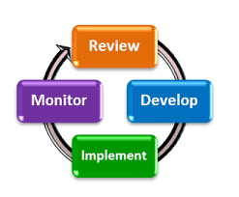

1. All professional learning must be approved in advance. The process for course registration includes:

• Consult with administrator

• Register for courses through the District’s electronic management system using Frontline

• Once approved, attend course/workshop

• Submit any documentation, if required.

The District may reimburse for travel expenses incurred while traveling on school related professional learning activities, with prior approval from the teacher’s administrator and District office administrator.

XI. RECORD KEEPING

1. Records of professional development hours will be kept according to New York State Department of Education regulations (Please see page 23).
2. It is the responsibility of each individual staff member to keep substantiated records of their own professional development including a running total of hours of professional development each year. Please see the CTLE section above on teacher/staff responsibilities and district responsibilities for documenting CTLE (Please see page 23).

XII. THE NORTH SALEM CENTRAL SCHOOL DISTRICT PROFESSIONAL

LEARNING TEAM

1. The North Salem Central School District Professional Learning Team (NSCSD PLT) is made up of teachers, support staff, and administrators with the teachers providing a majority of the members. Teachers from across the grade levels and disciplines and from regular and special education will be included. Each member shall have one vote when this action is necessary. A teacher/NSTA unit member will be the leader of this team and will be one of the North Salem representatives to the Teachers Center Board.
2. The NSCSD PL team will be allocated funds from the yearly BOE budget to fund some of the professional development activities and PL team.
3. The NSCSD PL team will collaborate with the staff and administration to develop the details of the yearly PL plan.
4. The duties of the Teacher Leader of the NSCSD PL Team will include:
5. Lead of the PL team in its collaboration with the staff and administration to focus the specifics of the yearly PL plan on the goals for student performance
6. Liaison between staff and PL team
7. Scheduling and facilitation of meetings of the PL team
8. Work with Director of Instruction and Human resource to manage the PL team budget to effectively implement the districts PL plan
9. Facilitate the process of approval of conferences submitted to the PL team
10. Assist in the coordination and implementation of programs offered through the PL team
11. Attend Teacher Center meetings and act as a liaison between the TC and NSCSD PL team.
12. Help to keep staff members informed of PL activities and the role of the PL team.
13. Collaborate in the evaluation and revision of the PL Master Plan and its yearly implementation.
14. The NSCSD PL Team will collaborate with the staff and administration to implement, evaluate, and revise this plan.
15. The NSCSD PL Team will collaborate with the administration in certifying that the Professional Learning Master Plan and its yearly supporting plans comply with state regulations regarding professional development.

XIII. COLLABORATION WITH THE HUDSON RIVER TEACHER CENTER

1. The NSCSD PL team will collaborate with the Teachers Center in the processes described in this plan.

XIV. PROFESSIONAL LEARNING SERVICE PROVIDERS (include but are not limited to the following:)

Digital Promise provides our faculty with training on computational thinking and digital fluency standards.

CBC staff conduct ongoing training to address treatment implementation, obstacles and solutions which include adaptations for site specific issues and troubleshooting.

Tri State provides our faculty with professional learning in the areas of performance based assessments, student metacognition, student performance data, curriculum and instruction, professional learning, equitable support for student needs, shared vision and environment for change, parent and community support.

LHRIC provides support for teachers and staff in the use of STAR assessments to guide instruction as well as data analysis, goal setting and the use of Schoolzilla.

PNW BOCES provides support in curriculum and instruction, SEL, assessment, and supports administration and staff through collegial circles targeted for specific disciplines and best practices.

Great Minds (Wit & Wisdom) provides professional learning for the onboarding of our new K-5 literacy program.